Libero mfg Analisi e errori

indice

1. Errore Java su esplosione /implosione BOM (Fatto )

2. Manufacturing workflow editor (Fatto )

3.Product Configuration BOM ( Fatto )

4.Planned Order Approval (Fatto )

5 . CRP Info Fatto

6.Distribution Order - Errore

7 . Generate Movement Manual - ERRORE

8 . Material Receipt Distribution Order - ERRORE

# 1. Errore Java su esplosione /implosione BOM (Fatto )

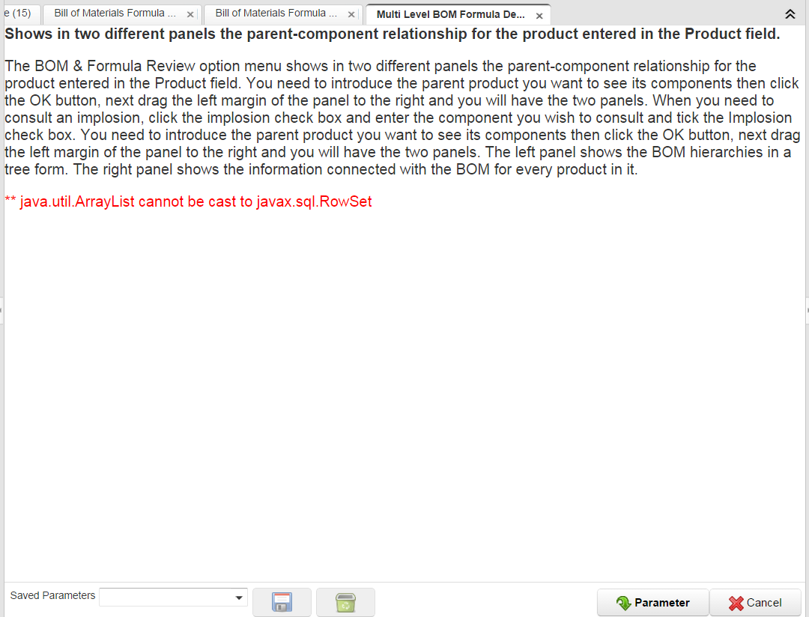

**OK RISOLTO (16/10/2014): modifica a mano nella classe**

**org.eevolution.process.PrintBOM (da riga 128 a riga 142)**

# 

# 

# 2. Manufacturing workflow editor (Fatto )

|  |
| --- |
| **Gestione Produzione \*\*\*** |
| **Manufacturing Management Setup** |
| **Ingegneria Gestionale \*\*\*** |
| **Change Notice** |
| **BOM Change Notice** |
| **Risorse Produzione\*\*\*** |
| **Manufacturing Resource** |
| **Manufacturing Workflow** |
| **Manufacturing Workflow Setup** |
| **Manufacturing Workflows** |
| **Manufacturing Workflow Editor** |

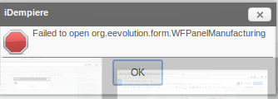

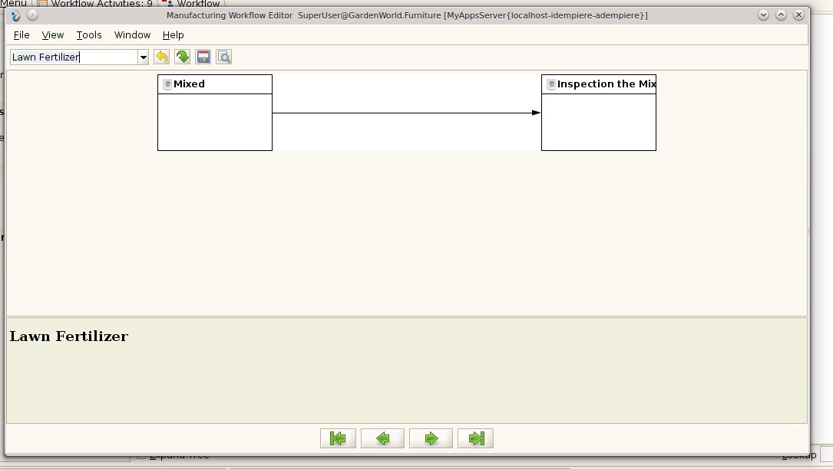

Classe: org.compiere.form.WFPanelManufacturing (/org.idempiere.LiberoMfg_forms)

**Risolto.**

per apertura maschera su WebUI:

creazione della classe

*org.eevolution.form.WFPanelManufacturing_web (/org.idempiere.liberomfg)*

Poi, creata l’estensione per org.adempiere.webui.Form



# 3.Product Configuration BOM ( Fatto )

|  |
| --- |
| **Distinta Base & Formule** |
| **Bill of Material & Formula Setup** |
| **Bill of Materials & Formula** |
| **Multi Level BOM & Formula Detail** |
| **Mutiple Components Change** |
| **Product Configuration BOM** |

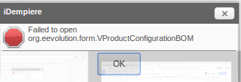

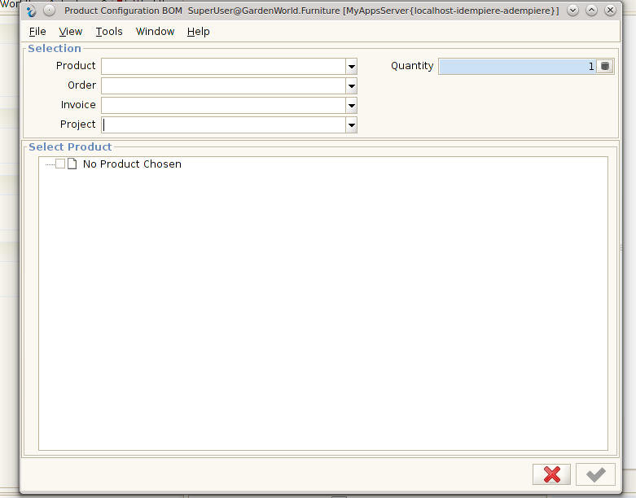

Classe: org.eevolution.form.VProductConfigurationBOM (/org.idempiere.LiberoMfg_forms)

**Risolto.**

per apertura maschera su WebUI:

creazione della classe

*org.eevolution.form.WProductConfigurationBOM (/org.idempiere.liberomfg)*

(...copia identica della classe *org.adempiere.webui.apps.form.WBOMDrop*….modifica su una query al metodo *org.eevolution.form.WProductConfigurationBOM.getProducts()*....)

Poi, creata l’estensione per org.adempiere.webui.Form (vedi sopra, al punto 2….)

CODICE:

Selezione lista prodotto:

/**

* Get Array of BOM Products

* @return products

*/

private KeyNamePair[] getProducts()

{

String sql = "SELECT M_Product_ID, Name "

+ "FROM M_Product "

+ "WHERE IsBOM='Y' AND IsVerified='Y' AND IsActive='Y' AND "

+ "M_Product_ID IN (SELECT M_Product_ID FROM PP_Product_bom

WHERE bomtype = 'C' AND bomuse = 'A') "

+ "ORDER BY Name";

return DB.getKeyNamePairs(MRole.getDefault().addAccessSQL(

sql, "M_Product", MRole.SQL_NOTQUALIFIED, MRole.SQL_RO),

true);

} // getProducts

Selezione lista ordine:

/**

* Get Array of open Orders

* @return orders

*/

private KeyNamePair[] getOrders()

{

String sql = "SELECT C_Order_ID, DocumentNo || '_' || GrandTotal "

+ "FROM C_Order "

+ "WHERE Processed='N' AND DocStatus='DR' "

+ "ORDER BY DocumentNo";

return DB.getKeyNamePairs(MRole.getDefault().addAccessSQL(

sql, "C_Order", MRole.SQL_NOTQUALIFIED, MRole.SQL_RO), true);

} // getOrders

Selezione lista progetti:

/**

* Get Array of open non service Projects

* @return orders

*/

private KeyNamePair[] getProjects()

{

String sql = "SELECT C_Project_ID, Name "

+ "FROM C_Project "

+ "WHERE Processed='N' AND IsSummary='N' AND IsActive='Y'"

+ " AND ProjectCategory<>'S' "

+ "ORDER BY Name";

return DB.getKeyNamePairs(MRole.getDefault().addAccessSQL(

sql, "C_Project", MRole.SQL_NOTQUALIFIED, MRole.SQL_RO), true);

} // getProjects

Selezione lista fatture:

/**

* Get Array of open Invoices

* @return invoices

*/

private KeyNamePair[] getInvoices()

{

String sql = "SELECT C_Invoice_ID, DocumentNo || '_' || GrandTotal "

+ "FROM C_Invoice "

+ "WHERE Processed='N' AND DocStatus='DR' "

+ "ORDER BY DocumentNo";

return DB.getKeyNamePairs(MRole.getDefault().addAccessSQL(

sql, "C_Invoice", MRole.SQL_NOTQUALIFIED, MRole.SQL_RO), true);

} // getInvoices

# 4.Planned Order Approval (Fatto )

|  |
| --- |
| **MRP \*\*\*\*** |
| **Material Requirement Planning Setup** |
| **Calculate Low Level** |
| **Create Record MRP** |
| **Calculate Material Plan** |
| **MRP Info** |
| **MRP Notice** |
| **MRP Notice (all)** |
| **View MRP Records** |
| **MRP Details** |
| **Planned Order Approval** |

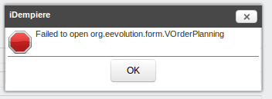

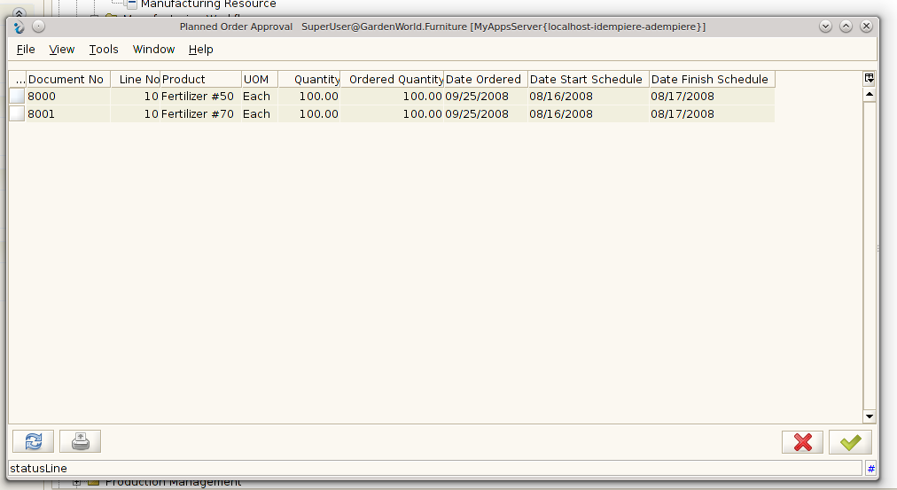

Classe: org.eevolution.form.VOrderPlanning (/org.idempiere.LiberoMfg_forms)

**Risolto.**

per apertura maschera su WebUI:

creazione InfoWindow : **Planned Order Approval - Info**

processo: org.eevolution.process.PlannedOrder

# 5 . CRP Info ( Fatto ) da completare 2° dataset

|  |
| --- |
| **CRP** |
| **Capacity Requirement Planning Setup** |
| **Calculate Capacity Plan** |
| **Resource Load View** |
| **CRP Info** |

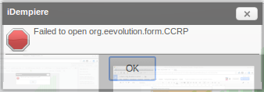

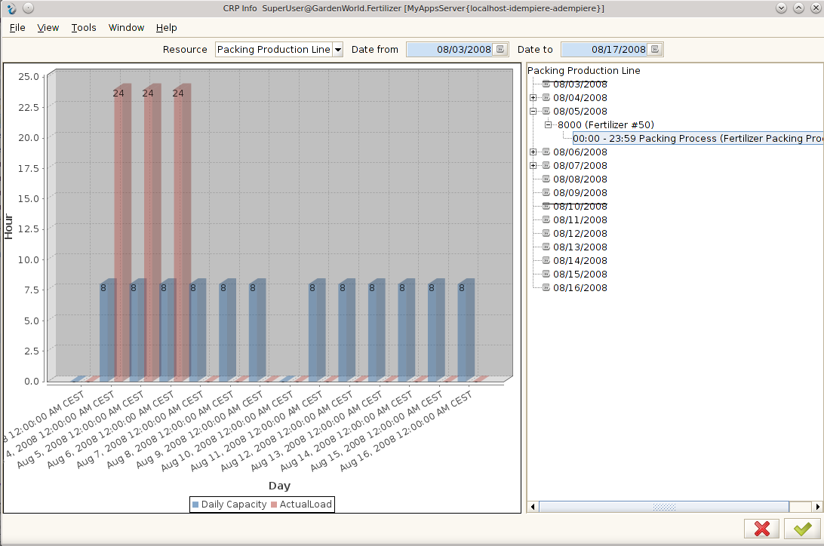

Classe: org.eevolution.form.CCRP (/org.idempiere.LiberoMfg_forms)

Relazione grafica del carico di lavoro di una risorsa

In primo luogo si ricerca la capacità giornaliera della risorsa: i dati che vengono utilizzati per il calcolo sono ***PercentUtilization, DailyCapacity*** ….dati forniti dalla tabella S_Resource

( *org.eevolution.form.crp.CRPDatasetFactory.getMaxRange(MResource)* )

Poi ?????

Query su cui si dovrebbe basare la creazione del grafico:

(N.B. per funzionare nel modo corretto, accertarsi che nella tab “*Manufacturing Order > Workflow > Order Activity*” i campi ‘*Date Start Schedule*’ e ‘*Date Finish Schedule*’ siano valorizzati…..)

**SELECT** SetupTimeReal,SetupTime,C_BPartner_ID,OverlapUnits,S_Resource_ID,IsMilestone,

DateStartSchedule,DateStart,DateFinish,Duration,Cost,AD_Column_ID,AD_Form_ID,

AD_Process_ID,AD_Task_ID,AD_WF_Block_ID,AD_Window_ID,ValidTo,DocStatus,

IsCentrallyMaintained,JoinElement,"limit",Priority,Help,QtyDelivered,SubflowExecution,

ValidFrom,QtyReject,DurationReal,IsSubcontracting,MovingTime,WaitingTime,WorkingTime,XPosition,YPosition,AD_Workflow_ID,PP_Order_Workflow_ID,PP_Order_Node_ID,"action",

PP_Order_ID,UnitsCycles,Yield,QtyScrap,QueuingTime,SplitElement,AttributeName,

Description,Name,DateFinishSchedule,Workflow_ID,StartMode,FinishMode,Value,

PP_Order_Node_UU,CreatedBy,AD_Org_ID,UpdatedBy,IsActive,DocAction,AD_Client_ID,

AttributeValue,AD_Image_ID,AD_WF_Node_ID,AD_WF_Responsible_ID,EntityType,

Created,Updated,DurationRequired,QtyRequired,SetupTimeRequired

**FROM** PP_Order_Node

WHERE

(S_Resource_ID=**50006** AND AD_Client_ID=**11**

AND (

(DateStartSchedule<='**2008-08-04 00:00:00.000000 +02:00:00**' AND

DateFinishSchedule>='**2008-08-04 00:00:00.000000 +02:00:00**' AND

DateFinishSchedule<='**2008-08-04 23:59:59.999000 +02:00:00**')

OR

(DateStartSchedule>='**2008-08-04 00:00:00.000000 +02:00:00**' AND

DateStartSchedule<='**2008-08-04 23:59:59.999000 +02:00:00**' AND

DateFinishSchedule>='**2008-08-04 00:00:00.000000 +02:00:00**' AND DateFinishSchedule<='**2008-08-04 23:59:59.999000 +02:00:00**')

OR

(DateStartSchedule>='**2008-08-04 00:00:00.000000 +02:00:00**' AND

DateStartSchedule<='**2008-08-04 23:59:59.999000 +02:00:00**' AND

DateFinishSchedule>='**2008-08-04 23:59:59.999000 +02:00:00**')

OR

(DateStartSchedule<='**2008-08-04 00:00:00.000000 +02:00:00**' AND

DateFinishSchedule>='**2008-08-04 23:59:59.999000 +02:00:00**')

)

)

**\*colore rosso: passaggio dei parametri….**

**Creazione di una window**: CRP Info Dashboard

**Tab**: CRP Info Dashboard>Dashboard = utilizzo di una Vista (e no Tabella…)

**Creazione Vista**: su maschera “Table and Column” creato la tabella/vista *PP_OrderDashboard* (...segno di spunta su campo ‘View’...), con i suoi campi;

dopo, nella sotto-tab “Table>View Component”, specificare la tabella da cui prendere i campi per la crezione della vista (??) e nella sottotab “Table>View Component>View Column” specifico i campi che interessano….

Poi cliccare pulsante “Validate View”....

# 6.Distribution Order - (Fatto)

|  |
| --- |
| **Gestione Distribuzione \*\*\*** |
| **Distribution Management Setup** |
| **Distribution Network** |
| **Distribution Order** |
| **Distribution Order Detail** |

….Window non attiva….. (??)

Dopo attivazione da System User: (vedi sotto)

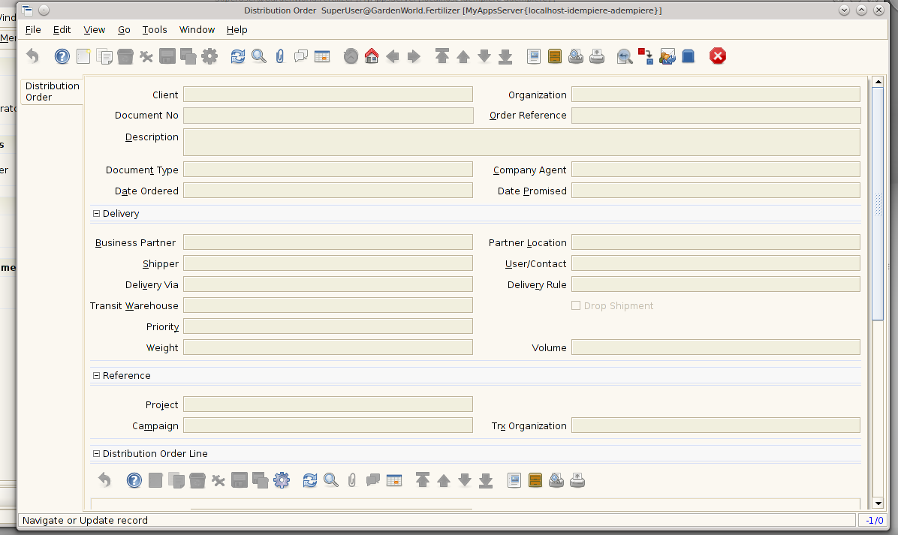

# 

# 7 . Generate Movement Manual - ( Fatto )

|  |
| --- |
| **Gestione Produzione \*\*\*** |
| **Manufacturing Management Setup** |
| **Ingegneria Gestionale \*\*\*** |
| **Planning Management \*\*\*** |
| **Gestione della Produzione \*\*\*** |
| **Gestione Distribuzione \*\*\*** |
| **Distribution Management Setup** |
| **Distribution Network** |
| **Distribution Order** |
| **Distribution Order Detail** |
| **Distribution List** |
| **Distribution Run Orders** |
| **Distribution Run** |
| **Generate Movement Manual** |

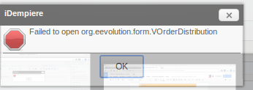

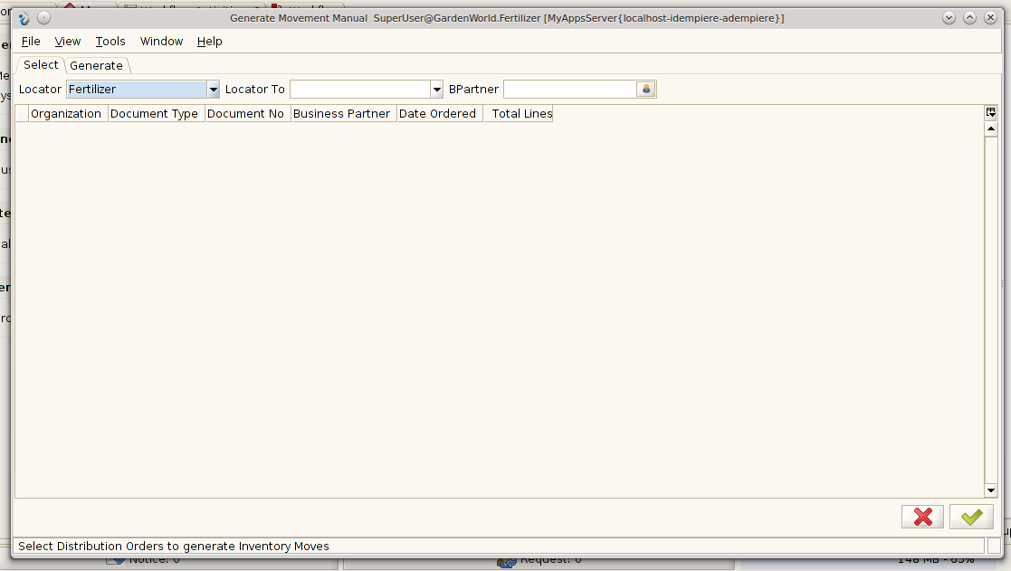

Classe: org.eevolution.form.VOrderDistribution (/org.idempiere.LiberoMfg_forms)

**Risolto.**

per apertura maschera su WebUI:

creazione della classe

*org.eevolution.form.WOrderDistribution (/org.idempiere.liberomfg)*

Poi, creata l’estensione per org.adempiere.webui.Form (vedi sopra, al punto 2….)

# 8 . Material Receipt Distribution Order - ERRORE

|  |
| --- |
| **Gestione Produzione \*\*\*** |
| **Manufacturing Management Setup** |
| **…….** |
| **Distribution Run Orders** |
| **Distribution Run** |
| **Generate Movement Manual** |
| **Generate Movement** |
| **Material Receipt Distribution Order** |

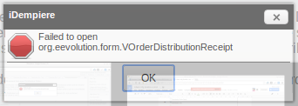

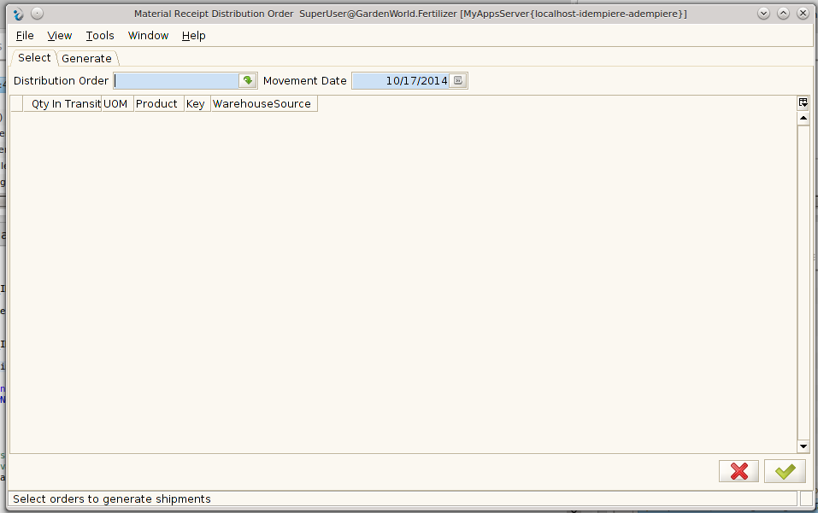

Classe: org.eevolution.form.VOrderDistributionReceipt (/org.idempiere.LiberoMfg_forms)

**Risolto.**

per apertura maschera su WebUI:

creazione della classe

*org.eevolution.form.WOrderDistributionReceipt (/org.idempiere.liberomfg)*

Poi, creata l’estensione per org.adempiere.webui.Form (vedi sopra, al punto 2….)